MASSACHUSETTS INSTITUTE OF TECHNOLOGY
Department of Physics

Problem Solving 2: Calculating the Electric Field of Continuous Charge Distributions

OBJECTIVES

- To look at the meaning of linear charge density, area charge density, and volume charge density.

- To calculate the electric field from a line of charge along two different directions.

- To examine the limiting behavior of the two expressions when the length of the line goes to zero, to make sure we recover the results we expect.

REFERENCE: Sections 2.9 – 2.10, 8.02 Course Notes.

PROBLEM SOLVING STRATEGIES

In Section 2.12 of the Course Notes, we discussed how the electric field at an observation point P is calculated for continuous charge distributions, and we repeat that discussion here. We must evaluate the vector integral

where is the distance from to and is the corresponding unit vector. To complete the integration, we follow the procedures outlined in your Course Notes and below:

- Start with

- Rewrite the charge element dq as

depending on whether the charge is distributed over a length, an area, or a volume.

(3) Substitute dq into the expression for.

(4) Specify an appropriate coordinate system (Cartesian, cylindrical or spherical) and express the differential element ( dl, dA or dV ) and r in terms of the coordinates (see Table 2.1 below for a summary.). If you need a review of the various coordinate systems, see Review Module on Coordinate Systems.

 | Cartesian (x, y, z) | Cylindrical (ρ, φ, z) | Spherical (r, θ, φ)

Table 2.1 Differential elements of length, area and volume in different coordinates.

(5) Rewrite in terms of the integration variable, and apply symmetry argument to identify non-vanishing component(s) of the electric field.

(6) Complete the integration to obtain .

PROBLEM 1: Continuous Charge Densities

Question 1 (Answer on the tear-sheet at the end!): A cylindrical shell of length and radius , with L >> R, is uniformly charged with total charge $Q$. We only place charge on the sides of the cylinder. The end caps of the cylinder have no charge.

- What is the surface charge density on the cylinder in terms of the variables given? Check units!

- Suppose you go very far away from the cylinder to a distance much greater than R. The cylinder now looks like a line of charge. What is the linear charge density of that apparent line of charge? Check units!

- What is relationship between your from (a) and your from (b)? Check units!

Question 2 (Answer on the tear-sheet at the end!): A solid cylinder of length and radius , with L >> R, is uniformly filled with a total charge $Q$.

- What is the volume charge density? Check units!

- Suppose you go very far away from the cylinder to a distance much greater than R. The cylinder now looks like a line of charge. What is the linear charge density of that apparent line of charge? Check units!

- What is relationship between your from (a) and your from (b) ? Check units!

The next two problems both deal with the electric field of a line of charge. We can only calculate that field analytically along two lines in space, both of which we do here. At other points we must do a numerical calculation. To see a global representation of what that electric field looks like everywhere, go to the ShockWave Visualization at http://web.mit.edu/8.02T/www/802TEAL3D/visualizations/electrostatics/index.htm and choose the fourth simulation from the top in the right column. The figure below is the grass seeds map from that simulation, and shows the global structure of the electric field.

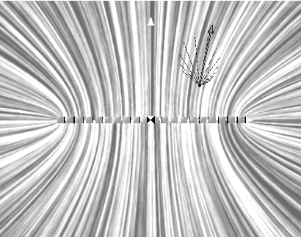

PROBLEM 2: Electric Field on the Axis of a Line of Charge

(Answer on the tear-sheet at the end!)

A wire of length has a uniform positive linear charge density (coulombs/meter) and a total charge . Calculate the electric field at a point located along the axis of the wire and a distance from one end.

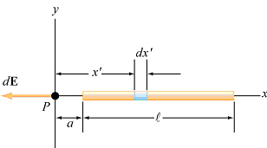
- Give an integral expression for the electric field at point P.

- Evaluate this integral.

- In the limit that the length of the rod goes to zero, does your answer reduce to the right expression?

PROBLEM 3: Electric Field along the Perpendicular Bisector of a Line of Charge

(Answer on the tear-sheet at the end!):

A rod of length L carries a charge per unit length λ uniformly distributed over its length.

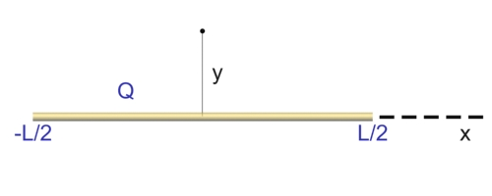

Find an integral expression for the electric field of the rod a distance y from the center of the rod along its perpendicular bisector (see sketch above)

MASSACHUSETTS INSTITUTE OF TECHNOLOGY
Department of Physics

Tear off this page and turn it in at the end of class !!!!

Note:
Writing in the name of a student who is not present is a Committee on Discipline offense.

Group ___________________________________ (e.g. 10A Please Fill Out)

Names ____________________________________

____________________________________

____________________________________

Problem Solving 2: Calculating the Electric Field of Continuous Charge Distributions

PROBLEM 1: Continuous Charge Densities

Question 1

- What is the surface charge density ?

- What is the linear charge density of the apparent line of charge?

- What is relationship between your from (a) and your from (b)?

Question 2

- What is the volume charge density ?

- What is the linear charge density of the apparent line of charge?

- What is relationship between your from (a) and your from (b) ?

PROBLEM 2: Electric Field on the Axis of a Line of Charge

- Give an integral expression for the electric field at point P.

- Evaluate this integral between the appropriate limits.

- In the limit that the length of the rod goes to zero, does your answer in (b) reduce to the right expression? Show why this.

PROBLEM 3: Electric Field along the Perpendicular Bisector of a Line of Charge

Give an integral expression for the electric field of the rod a distance y from the center of the rod along its perpendicular bisector.

