Weird Fields Contest

Look at the 2 top vote getters (tied for first place!) on the handout sheet and vote for the one you find most appealing or striking.

1.
2.

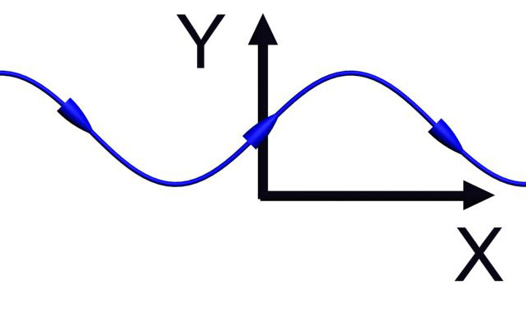

The field line above corresponds to the vector field:

1.
2.
3.
4.
5. I don’t know

Answer: (4)

The curve above has a slope of 1 at the origin, and only (3) or (4) has this property. Moreover, the tangent to the curve above has a y-component changes sign as x changes and an x-component that is always positive, so the answer must be (4).

The above vector field is created by:

1. Two sources (equal strength)
2. Two sources (top stronger)
3. Two sources (bottom stronger)
4. Source & Sink (equal strength)
5. Source & Sink (top stronger)
6. Source & Sink (bottom stronger)
7. I don’t know

(3) Two sources, bottom stronger

Both sources because lines leaving one don’t enter the other.
Bottom is stronger because it “pushes” further
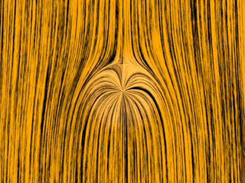

Here there is an initial downward flow.

1. The point is a source
2. The point is a sink
3. I don’t know

(1) Source (Animation)

It’s a source, because otherwise the downward flow would flow right into it.

NOTE: If the background were upward, then it would be just flowing right into it, so it would be a sink.


These two circulations are in:

1. The same direction
(e.g. both clockwise)
2. Opposite directions
(e.g. one clockwise, one ccw)
3. I don’t know

(2) Opposite directions (Animation)

You can tell by looking in between. Both circulations push the flow in the same direction, so they must be circulating counter to each other.

Animation with same direction

The “grass seeds” field plot above is a representation of the vector field:
5. NOT SURE

Look along the positive x-axis. Along this axis the grass seed textures are vertical. This means F has only a y component when y is zero and x is non-zero. Only consistent with (2).
Two opposite charges are placed on a line as shown below. The charge on the right is three times larger than the charge on the left. Other than at infinity, where is the electric field zero?

q_{L}
q_{R}

1. Between the two charges
2. To the right of the charge on the right
3. To the left of the charge on the left
4. The electric field is nowhere zero
5. Not enough information – need to know which charge is positive
q_{L}
(3) Zero is left of q_{L}.
q_{R}

Between field goes from source to sink.
On right, field is dominated by q_{R} (bigger & closer).
On left, because q_{L} is weaker, its “push” left will somewhere be balanced by q_{R}’s “pull” to the right

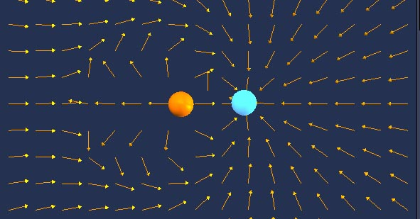

Electric field lines in the space surrounding a charge distribution show:

1. Directions of the forces that exist in space at all times.
2. Only directions in which static charges would accelerate when at points on those lines
3. Only directions in which moving charges would accelerate when at points on those lines.
4. Directions in which either static or moving charges would accelerate when passing through points on those lines.
5. Paths static or moving charges would take.

(4) Direction of acceleration of charges either “in” or “moving through”

NOTE: This is different than flow lines (5). Particles do NOT move along field lines.
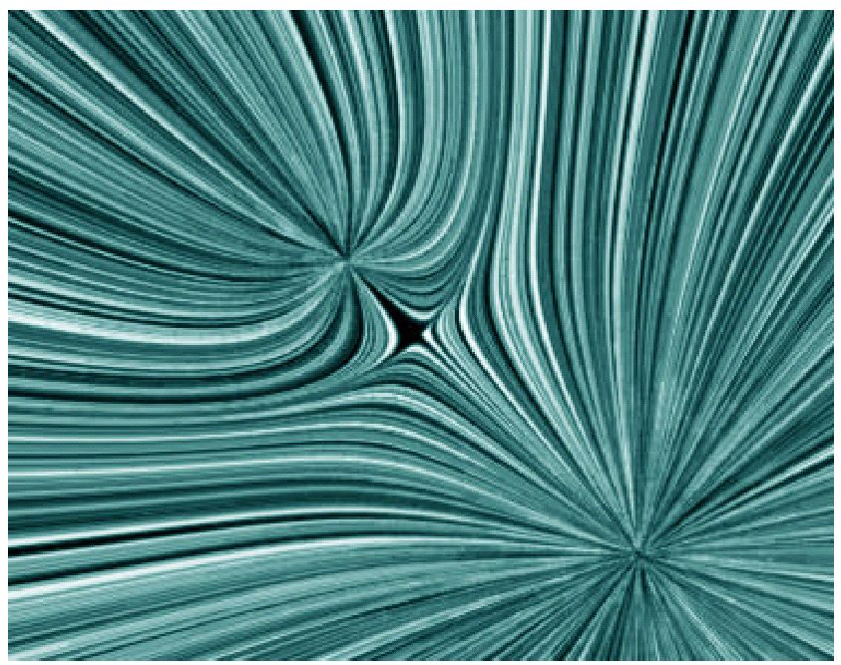

The force between the two charges is:
1) Attractive
2) Repulsive
3) Can’t tell without more information

(2) Repulsive

One way to tell is to notice that they both must be sources (or sinks). Hence, as like particles repel, the force is repulsive.

You can also see this as tension in the field lines
E-Field of Two Equal Charges
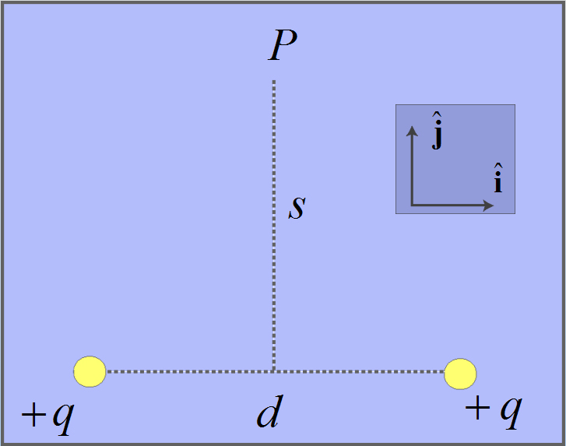
Electric field at point P is:
1. 2.

3. 4.

5. Don’t Know
E-Field of Two Equal Charges

1.

There are a several ways to see this. For example, consider d→0. Then,
which is what we want (sitting above a point charge with charge 2 q)

E-Field of Five Equal Charges
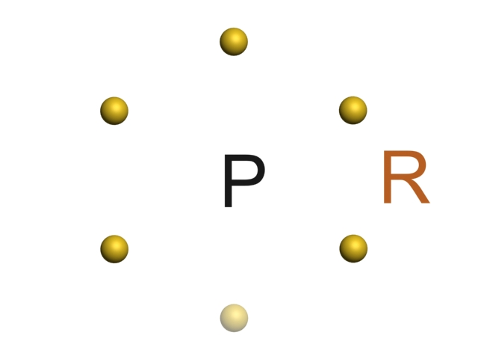
Six equal positive charges q sit at the vertices of a regular hexagon with sides of length R. We remove the bottom charge. The electric field at the center of the hexagon (point P) is:
1. 2.
3. 4.
- 6. Don’t know
E-Field of Five Equal Charges
4.
The electric field at the center is due to two pairs of charges across the diagonal and the unpaired top charge. The electric fields of the two pairs of charge will cancel at the center by symmetry. Therefore the electric field at the center is due only to the top charge. The distance to the top charge is R, and the field points downward.
E-Field of a Dipole

As you move to large distances r away from a dipole, the electric field will fall-off as:
1) 1/r², just like a point charge
2) More rapidly than 1/r²
3) More slowly than 1/r²
4) Who knows?
E-Field of a Dipole

(2) It falls off more rapidly

We know this must be a case by thinking about what a dipole looks like from a large distance. To first order, it isn’t there (net charge is 0), so the E-Field must decrease faster.
An electric dipole, consisting of two equal and opposite point charges at the ends of an insulating rod, is free to rotate about a pivot point in the center. The rod is placed in a non-uniform electric field.
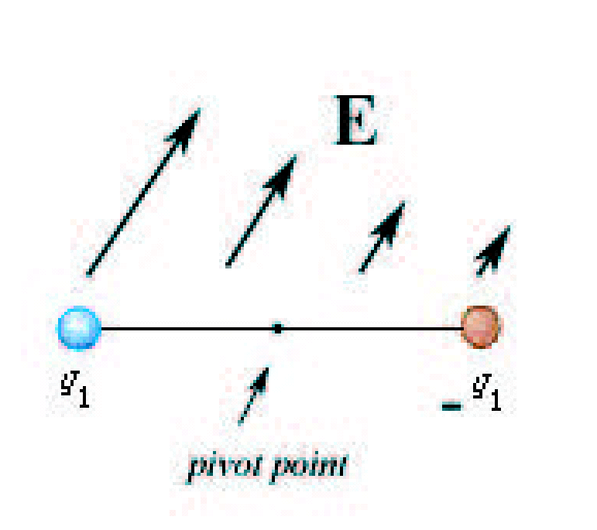
The dipole will experience
1. a noticeable electric force and no noticeable electric torque
2. no noticeable electric force and a noticeable electric torque
3. a noticeable electric force and a noticeable electric torque
4. no noticeable electric force and no noticeable electric torque

(3) A noticeable force and torque

Because the field is non-uniform, the force on the two equal but opposite point charges do not cancel.

As always, the dipole will rotate to align with the field, hence there must be a torque on the dipole as well

Masses in Potentials

Consider 3 equal masses sitting in different gravitational potentials:
A) Constant, zero potential
B) Constant, non-zero potential
C) Linear potential (V ∝ x) but sitting at V = 0

Which statement is true?
1. None of the masses will accelerate
2. Only B will accelerate
3. Only C will accelerate
4. All masses will accelerate, but B will have the largest acceleration
5. All masses will accelerate, but C will have the largest acceleration
Masses in Potentials

(3) Only C (in linear potential) will accelerate

When you think about potential, think “height.” For example, near the Earth:

U = mgh so V = gh

Constant potential (think constant height) thus will not cause acceleration. The value of the potential (height) is irrelevant.

Positive Charge

Place a positive charge in an electric field. It will move from

1. higher to lower electric potential; lower to higher potential energy

2. higher to lower electric potential; higher to lower potential energy

3. lower to higher electric potential; lower to higher potential energy

4. lower to higher electric potential; higher to lower potential energy
Positive Charge

(2) From higher to lower potential and higher to lower potential energy

Objects always move to reduce their potential energy. Positive charges do this by moving towards a lower potential:

U = qV
Negative Charge

Place a negative charge in an electric field. It will move from

1. higher to lower electric potential; lower to higher potential energy

2. higher to lower electric potential; higher to lower potential energy

3. lower to higher electric potential; lower to higher potential energy

4. lower to higher electric potential; higher to lower potential energy
Negative Charge

(4) From lower to higher potential and higher to lower potential energy

Objects always move to reduce their potential energy. Negative charges do this by moving towards a higher potential:

U = qV
Potential and Energy

Which is true?
I. It takes positive work to bring like charges together.
II. Electric field lines always point in the direction of decreasing electric potential.
III. If a negative charge moves in the direction of the electric field, its potential energy decreases.
1. II only.
2. II and III only.
3. I, II and III.
4. I and II only.
5. I only.

Potential and Energy

(4) I and II Only

I. It takes positive work to bring like charges together. TRUE

II. Electric field lines always point in the direction of decreasing electric potential. TRUE

III. If a negative charge moves in the direction of the electric field, its electric potential energy decreases.
FALSE – potential decreases so potential energy increases (U = qV)
Two Point Charges

The work done in moving a positive test charge from infinity to the point P midway between two charges of magnitude +q and –q:
+q
-q
P
1. is positive.
2. is negative.
3. is zero.
4. can not be determined since not enough information is given.
5. I don’t know
Two Point Charges

(3) Work from ∞ to P is zero

+q
-q
P

The potential at ∞ is zero.
The potential at P is zero because equal and opposite potentials are superimposed from the two point charges (remember: V is a scalar, not a vector)
Potential Landscape

If I think of the electric potential as a mountain range, then the electric field points:

1) Up the mountain sides
2) Down the mountain sides
3) Around the mountain sides
4) I don’t know
Potential Landscape

(2) The electric field points the fastest way down the potential mountain – in the same way that the gravitational field tells you to come down

E from V
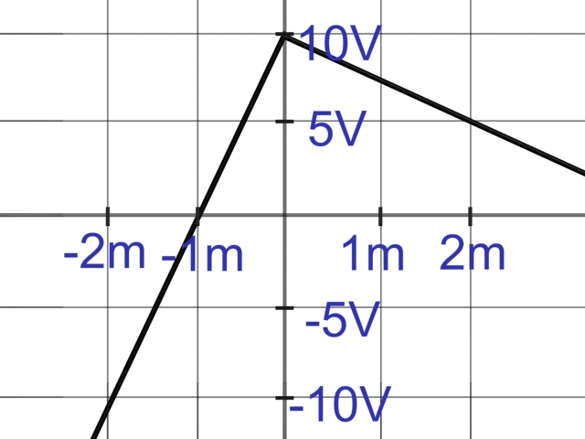

The graph above shows a potential V as a function of x. The magnitude of the electric field for x > 0 is
- larger than that for x < 0
- smaller than that for x < 0
- equal to that for x < 0
- I don’t know
E from V

(2) The electric field for x > 0 is smaller than that for the electric field for x < 0 because the slope of the potential is smaller in the region x> 0 as compared to x < 0. Translation: The hill is steeper on the left than on the right.
E from V

The graph above shows a potential V as a function of x. Which is true?
- E_{x > 0} is > 0 and E_{x < 0} is > 0
- E_{x > 0} is > 0 and E_{x < 0} is < 0
- E_{x > 0} is < 0 and E_{x < 0} is < 0
- E_{x > 0} is < 0 and E_{x < 0} is > 0
- I don’t know
E from V

(2) The electric field for x > 0 is in the positive x-direction, because as x decreases for x > 0 the potential increases, which can only happen if the electric field opposes movement to smaller x for x > 0. Translation: “Downhill” is to the left on the left and to the right on the right.
Flux Direction

The flux through the planar surface below (positive unit normal to left)
+q
-q
1. is positive.
2. is negative.
3. is zero.
4. I don’t know
Flux Direction

(2) The flux is negative

The field lines go from left to right, opposite the assigned normal direction. Hence the flux is negative.
+q
-q
Flux Through Sphere

+q
+q

The total flux through the above spherical surface is

1. positive.
2. negative.
3. zero.
4. I don’t know
Flux Through Sphere

+q
+q
(3) The total flux is zero
We know this from Gauss’s Law:
There is no enclosed charge so no net flux. The flux in on the left is cancelled by the flux out on the right.
Should We Use Gauss’ Law?

For which of the following uniform charge distributions can we use Gauss’ Law to determine the electric field?

A. Concentric nested spherical shells
B. Non-concentric nested spherical shells
C. Finite line of charge
D. Infinite line of charge
E. Thin, infinite, sheet of charge
F. Thick, infinite, slab of charge

1. None of them 2. All of them
3. A, B, C only 4. D, E, F only
5. A, D, E, F only 6. C, D only
7. A, D, E only 8. C, D, E, F only
Should We Use Gauss’ Law?

(5) A, D, E & F

In order to effectively use Gauss’ law, the charge distribution must have either spherical, cylindrical or planar symmetry.

- Concentric spheres have spherical symmetry, non-concentric do not
- Infinite lines have cylindrical symmetry, finite do not
- Infinite planes and slabs of charge both exhibit planar symmetry
Spherical Shell

We just saw that in a solid sphere of charge the electric field grows linearly with distance. Inside the charged spherical shell at left (r<a) what does the electric field do?
a
Q

1. Constant and Zero
2. Constant but Non-Zero
3. Still grows linearly
4. Some other functional form (use Gauss’ Law to determine)
5. Can’t determine with Gauss Law
Spherical Shell

1. Constant and Zero

We have spherical symmetry so we can use Gauss’ Law with a spherical surface. Any surface inside the spherical shell will contain no charge and hence have no flux through it. E = 0!
E Field from Slab

A positively charged, semi-infinite flat slab has thickness D.

The z-axis is perpendicular to the sheet, with center at z = 0.
D
ρ
z = 0
z

At the plane’s center (z = 0), E
1. points in the positive z-direction
2. points in the negative z-direction
3. is zero
4. I don’t know
E Field from Slab

(3) At the center of the slab the electric field is 0.
D
ρ
z = 0
z
Symmetry tell us this – the amount of charge above and below the center of the plane is equal hence the fields cancel.
Another way of saying this is that since you don’t know which way the field would point it must be 0.
E Field from Slab

A positively charged, semi-infinite flat slab has thickness D.
The z-axis is perpendicular to the sheet, with at z = 0.
D
ρ
z = 0
z
A distance z from its central plane,
E Field from Slab

(4) E is proportional to z inside the slab.
D
ρ
z = 0
z

As you move away from the center, an imbalance is generated in the amount of charge below you and the amount above you. This imbalance grows linearly with z, and is what leads to the E field that you see.

Once outside the slab, the imbalance stops changing so the field is constant.
Walking Down a Mountain

Consider the topo. map at left. Starting at the center of the dot, which direction starts you downhill the fastest?
N

1. N 2. NE
3. E 4. SE
5. S 6. SW
7. W 8. NW

Walking Down a Mountain

(1) Start off going North
N
The fastest way downhill (or uphill) is always to walk perpendicular to contours of constant height. From the peak the fastest way down is NW, but from here it is N.
Changing C Dimensions
A parallel-plate capacitor has plates with equal and opposite charges ±Q, separated by a distance d, and is not connected to a battery. The plates are pulled apart to a distance D > d.
What happens to the potential difference V and the charge Q?
1. V increases, Q increases
2. V decreases, Q increases
3. V is the same, Q increases
4. V increases, Q is the same
5. V decreases, Q is the same
6. V is the same, Q is the same
7. V increases, Q decreases
8. V decreases, Q decreases
9. V is the same, Q decreases
Changing C Dimensions

(4) V Increases, Q remains the same

With no battery connected to the plates the charge on them has no possibility of changing.

In this situation, the electric field doesn’t change when you change the distance between the plates, so:

V = E d

As d increases, V increases.
Changing C Dimensions
A parallel-plate capacitor has plates with equal and opposite charges ±Q, separated by a distance d, and is connected to a battery. The plates are pulled apart to a distance D > d.
What happens to the potential difference V and the charge Q?
1. V increases, Q increases
2. V decreases, Q increases
3. V is the same, Q increases
4. V increases, Q is the same
5. V decreases, Q is the same
6. V is the same, Q is the same
7. V increases, Q decreases
8. V decreases, Q decreases
9. V is the same, Q decreases
Changing C Dimensions

(9) V is the same, Q decreases

With a battery connected to the plates the potential V between them is held constant

In this situation, since

V = E d

As d increases, E must decrease.

Since the electric field is proportional to the charge on the plates, Q must decrease as well.
Changing C Dimensions

A parallel-plate capacitor, disconnected from a battery, has plates with equal and opposite charges, separated by a distance d.
Suppose the plates are pulled apart until separated by a distance D > d.
How does the final electrostatic energy stored in the capacitor compare to the initial energy?

1. The final stored energy is smaller
2. The final stored energy is larger
3. Stored energy does not change.
Changing C Dimensions

(2) The stored energy increases

As you pull apart the capacitor plates you are increasing the amount of space in which the E field is non-zero and hence increase the stored energy. Where does the extra energy come from? From the work you do pulling the plates apart.

Hollow Conductors
A point charge +Q is placed at the center of the conductors. The induced charges are:

1. Q(I1) = Q(I2) = -Q;
Q(O1) = Q(O2)= +Q

2. Q(I1) = Q(I2) = +Q;
Q(O1) = Q(O2)= -Q

3. Q(I1) = -Q; Q(O1) = +Q
Q(I2) = Q(O2)= 0

4. Q(I1) = -Q; Q(O2)= +Q
Q(O1) = Q(I2)= 0
Hollow Conductors

(1) The inner faces are negative, the outer faces are positive.

Looking in from each conductor, the total charge must be zero (this gives the inner surfaces as –Q). But the conductors must remain neutral (which makes the outer surfaces have induced charge +Q).
Hollow Conductors
A point charge +Q is placed at the center of the conductors. The potential at O1 is:

1. Higher than at I1

2. Lower than at I1

3. The same as at I1
Hollow Conductors

(3) O1 and I1 are at the same potential

A conductor is an equipotential surface. O1 and I1 are on the same conductor, hence at the same potential

Hollow Conductors
A point charge +Q is placed at the center of the conductors. The potential at O2 is:

1. Higher than at I1

2. Lower than at I1

3. The same as at I1
Hollow Conductors

(2) O2 is lower than I1

As you move away from the positive point charge at the center, the potential decreases.

Hollow Conductors
A point charge +Q is placed at the center of the conductors. If a wire is used to connect the two conductors, then positive charge will flow

1. From the inner to the outer conductor

2. From the outer to the inner conductor

3. Not at all
Hollow Conductors

(1) Positive charge flows outward

Positive charges always flow “downhill” – from high to low potential. Since the inner conductor is at a higher potential the charges will flow from the inner to the outer conductor.

Capacitor Circuit

Three identical capacitors are connected to a battery as pictured.
The battery is then disconnected.
C
B
A
How do the charge on A, B & C compare before and after the battery is removed?

BEFORE; AFTER
1. Q_{A} = Q_{B} = Q_{C}; No Change
2. Q_{A} = Q_{B} = Q_{C}; Q_{A} > Q_{B} = Q_{C}
3. Q_{A} = Q_{B} = Q_{C}; Q_{A} < Q_{B} = Q_{C}
4. Q_{A} > Q_{B} = Q_{C}; No Change
5. Q_{A} > Q_{B} = Q_{C}; Q_{A} = Q_{B} = Q_{C}
6. Q_{A} < Q_{B} = Q_{C}; No Change
7. Q_{A} < Q_{B} = Q_{C}; Q_{A} = Q_{B} = Q_{C}

Capacitor Circuit

4. Q_{A} > Q_{B} = Q_{C}; No Change

C
B
A
The potential drop across A is the same as the sum of the potential drops across B & C. By symmetry V_{B}=V_{C}, so

V_{A} > V_{B}=V_{C}

Since Q = CV, Q_{A} > Q_{B} = Q_{C}. When the battery is disconnected there is no reason for the potential to change or charge to flow so it doesn’t.
Dielectric in a Capacitor

A parallel plate capacitor is charged to a total charge Q and the battery removed. A slab of material with dielectric constant κ in inserted between the plates. The charge stored in the capacitor

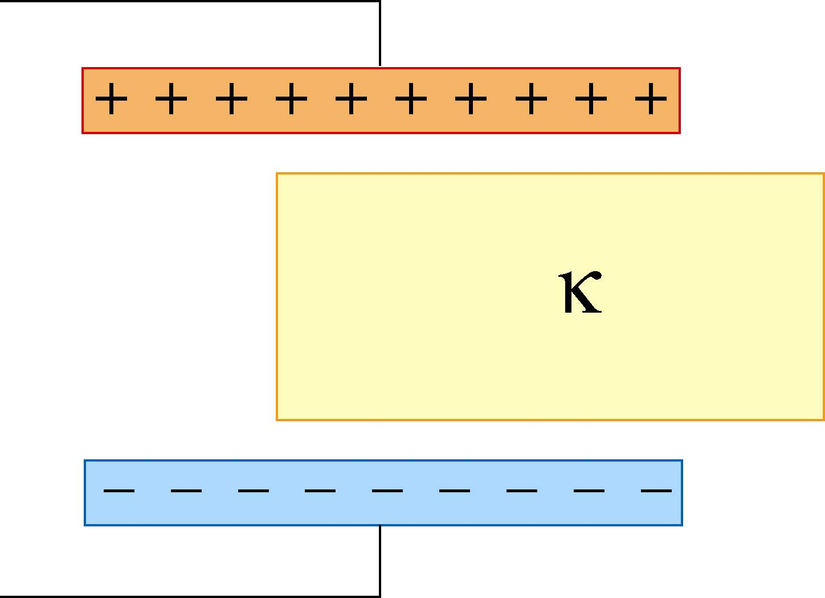

1. Increases
2. Decreases
3. Stays the Same
Dielectric in a Capacitor

(3) The charge is unchanged

Since the capacitor is disconnected from a battery there is no way for the amount of charge on it to change.
Dielectric in a Capacitor

A parallel plate capacitor is charged to a total charge Q and the battery removed. A slab of material with dielectric constant κ in inserted between the plates. The energy stored in the capacitor

1. Increases
2. Decreases
3. Stays the Same
Dielectric in a Capacitor

(2) The energy stored decreases

The dielectric reduces the electric field and hence reduces the amount of energy stored in the field.
Dielectric in a Capacitor

A parallel plate capacitor is charged to a total charge Q and the battery removed. A slab of material with dielectric constant κ in inserted between the plates. The force on the dielectric

1. pulls in the dielectric
2. pushes out the dielectric
3. is zero
Dielectric in a Capacitor

(1) The dielectric is pulled into the capacitor

We just saw that the energy is reduced by the introduction of a dielectric. Since systems want to reduce their energy, the dielectric will be sucked into the capacitor.

Alternatively, since opposing charges are induced on the dielectric surfaces close to the plates, the attraction between these will lead to the attractive force.

